# Package UML

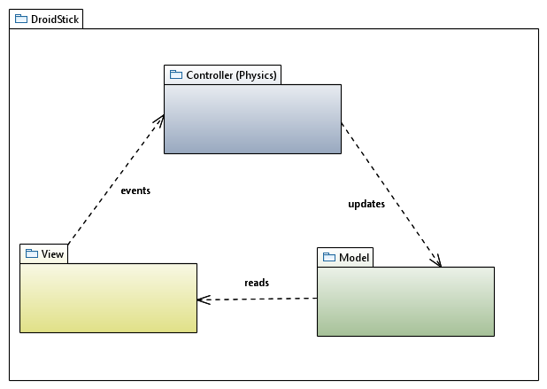

# Class Diagram UMLC:\Users\Francisco\Desktop\TSSGameClass.png

# Controller Class Diagram UML

# C:\Users\Francisco\Desktop\TSSGameClass.png

# Design Patterns

### Singleton

Used in “GameModel” class to guarantee only one instance of the Game state is running at a time, while making it easy to access from anywhere in the project.

Classes: GameModel

### Strategy

Used for different enemy types that share many common attributes. Allows defining a different movement and/or shooting A.I. per each enemy type.

Classes: Enemy, EnemyBehaviour, Enemy_Concrete1, Enemy_ConcreteN

### State

State machine for game logic (main menu, playing, game over).

Classes: GameModel, GameState, State_1, State_N